

Project Initiation Document

P20/P21: Modern Data Platform

*The Business Requirements Document and Project Initiation Document are both critical documents that need business input and review. It is well evidenced that time spent on reviewing and agreeing these documents early in the project lifecyle will save time later on.*

*The Project Initiation Document should be developed in parallel with the Business Requirements Document and the Architecture Blueprint as they are inherently inter-related as part of the delivery of the initiation phase of a project.*

Document Control

| **Version** | **Dated** | **Author** | **Reason for revision** |
| --- | --- | --- | --- |
| 0.1 | 15/06/2022 | Sagar Patel (PMO) | First version |
| 0.2 |  |  | Updated approvers and Benefits instructions |

Approvers[1]

|  |  |
| --- | --- |
| **Name** | Role |
| Shane Kingston | Business Sponsor |
| Kanika Chaganty | Chief Data Officer |
|  |  |
|  |  |
|  |  |

*Mandatory Approvers along with Business Sponsor

Reviewers[2]

| Name | Role | Confirmation of review |
| --- | --- | --- |
|  | Head of |  |
|  |  |  |
|  |  |  |
|  |  |  |
|  |  |  |

Contents

1 Context

2 Project Definition 4

3 High Level Solution Design 5

4 Implementation Approach 6

5 Plan on a Page 7

5.1 Key Milestones 8

6 Issue, Risk, Assumptions & Dependencies 8

6.1 Issues 8

6.2 Risks 8

6.3 Assumptions 8

6.4 Dependencies 8

7 Business Case 10

7.1 Estimated Project Costs 10

7.2 Benefits 11

8 Governance of the Project 12

8.1 Steering Committee Terms of Reference 12

8.1.1 Members 12

8.1.2 Frequency / Duration 12

8.1.3 Inputs 12

8.1.4 Outputs 13

8.2 Working Group Membership: 13

8.3 Project Team: 13

9 Project Deliverables 13

10 Mandatory Checklists 16

10.1 General Data Protection Regulation (GDPR) checklist 16

10.2 SOX Financial Controls Framework 17

10.3 Cyber Engagement Checklist 17

11 Engagement Checklist 17

# Context

|  |
| --- |
| **Issue / Reason for Change** |
| The data platform modernisation platform is replacing the current data and analytics estate that was delivered on Microsoft Azure previously. The existing data and analytics estate has a high cost of operation and time to value is slow, which has led to multiple instances of the solution being created to allow different user groups across the business to work with the data they need within their respective areas. |

# Project Definition

|  |
| --- |
| **Project objectives** |
| * Increase the total value created and sustained by the modernised data platform through delivering high value data and analytics use cases that enable economic, strategic or stakeholder value. This will initially be delivered through structured data and classical data warehouse-like processing and then will later expand to unstructured data processing. * Reset the cost: benefit dynamic of the data and analytics estate so that the current growth rate in technology costs is far lower and return on investment is gained within 3 years * Rationalise the data processing activities within the data and analytics estate so that we ingest and process the same data once so that different business areas no longer must perform their own data processing. * Establish the data platform with an effective set of tooling and software delivery processes that enable increased time to value and mitigate the need for different user groups needing to create their own duplicate instances or data satellites. * Create a data platform that is based on the lowest level of data possible, that is quality checked and has been validated for accuracy relevant to the user group consuming the data so that everyone has trust in the data. |

|  |  |  |  |
| --- | --- | --- | --- |
| **Execution- Desired start date:** | **01/05/2022** | **Execution - Desired end date** | **30/06/2024** |
| Driver for desired end date | *Explain what is driver for the desired end date. It is regulatory, or business cycle, or market opportunity, etc …* | | |

|  |
| --- |
| **In scope** |
| The scope of this solution will see the re-integration of the different instances of the current data and analytics estate into a single platform, along with the delivery of several high value use cases gathered from business stakeholders. The scope includes:   * Ingestion (or migration) of all existing source data from the current MyMI solution into the new data platform * Alignment of the six instances of the current data platform into the modernised data platform, where the data will be aligned to a universal data model * An exercise to remove the redundant copies of data upon the re-integration of the different instances of the existing data platform * Optimisation of the data ingestion pipeline to make it fast and cost efficient to process data, supporting primarily batch data as well as event-based data * Alignment of reporting and analytics to a new set of technology that will be fit for purpose for the next 3-5 years, including:   + Management information for business areas   + Regulatory reporting   + Exploratory analysis and ad-hoc querying and reporting   + o Data science experimentation, development and model execution / management |

|  |
| --- |
| **Out of scope** |
| The solution will not be designed to support the operational processes that require data adjustment processes to be submitted and processed e.g. the posting of finance journals to support accounting adjustments |

# High Level Solution Design

|  |
| --- |
| **High Level Solution Design** |
| The following design principles relate to the data platform modernisation and should be used to shape the design, operation and consumption of data and analytics within Brit.   1. Sources:   1.1 Capture all data in a standard way during business process interactions even if not of immediate use  1.2 Source data is pushed once, not pulled multiple times by consuming systems to reduce source copies of data  1.3 All data is published with metadata by the source system in order to enable solution automation and configuration, not coding   1. Acquisition & Transfer   2.1 Acquisition and transfer is decoupled from source and target technologies to increase portability  2.2 Standard and automated data acquisition of business and process data, not manual inputs and uploads  2.3 Acquire data in a controlled yet fast way to let the user community innovate, experient and create value   1. Data Storage and Processing   3.1 Curate justified, purposeful datasets based on the enterprise models and approved processing logic that will support multiple users and types of usage  3.2 Integrate relevant data published by source into a single version of truth that is made available to all that need it  3.3 Store all data in its rawest form upon ingestion, supporting the native format and a commonly consumable format   1. Quality, Governance, Security, Private, Ops, Resilience   4.1 Tokenise sensitive data by default for downstream consumption using data volumes appropriate to the data activity  4.2 The processing logic, lineage, quality, auditability and business accuracy of data is managed at every stage of the lifecycle and visible to consumers  4.3 Data has clearly defined processing rules that enable accurate application of data lifecycle management and retention  4.4 Everything is automated so that the operational resilience and supportability scales at a slower pace to data growth  4.5 Data access and movement is performed for value creation activities and is logged, audited and monitored  4.6 Data Security and data volume rules are applied at the point of data access in order to enable people to use no more data than they need  4.7 High standard of engineering practices are evidenced in order to demonstrate alignment to the software development lifecycle  4.8 Look to consolidate and deduplicate replicas of data as early in the lifecycle as possible so that we build high trust in the data  4.9 Data is discoverable to users and has clear and consistent business friendly terms that link to the glossary and data catalogue, the data owners and the stewards that govern their data   1. Creating Value from Data   5.1 Drive value from data by maintaining the meaning, lineage and quality of information in order to make data quick to understand  5.2 Work on sustainable data and analytics initiatives where the cost is appropriate to the value it generates  5.3 Create value from data with datasets in environments that are proportional to business needs and technical requirements   1. Consumers   6.1 Data is delivered in a format, volume and environment that is appropriate for the use case and the user’s skills  6.2 Data users have access to standard, consistent and purposeful cloud tooling where users are responsible for their cloud consumption  6.3 An optimal number of data copies and data movement will be maintained until the time the analysis becomes redundant  The high-level logical design of the modernised data platform follows the data lakehouse pattern. This allows for data to be sourced and retained in its raw format in commodity data storage and processed to validate quality and trustworthiness. Data consumers can use data from different parts of the solution based on their needs, data analysis techniques they wish to use and the level of data quality and trust they need to place in the data.    The target architecture requires the following technical components to be enabled to fulfil the requirements and enable the value of the data platform. The platform includes the ability for data to be processed in batch and events, which means that modernised data platform will be API enabled and will be a key catalyst in helping the business become further API driven in the future. |
|  |

# Implementation Approach

|  |
| --- |
| **Implementation approach** |
| The following workstreams will be run May 2022 – Mid 2024 and will deliver outputs and business value iteratively.  Workstream 1 – POC - The goal of this PoC is to show that the new cloud native solution for the modern data platform can work in a streamlined, performant and costeffective way – target is at least a 50% improvement in both time and cost in comparison with MyMi. The POC intentionally uses a scenario already implemented in MyMI to enable direct comparison between the As-Is and the To-Be solutions.  Workstream 2 – Technical Enablement - The goal of this workstream is to get all the required wiring, environments and data engineering setups in place to automate deployment, automate testing etc.  Workstream 3 – Delegated - The goal of this workstream is to address one of the big gaps in Brit’s data setup. It will centralise data at the right level of granularity, automate data ingestion process & improve quality of data.  Workstream 4 – Open Market - Iterative deliver use cases relating to data for the Open Market channe  Workstream 5 – Digital - Iterative deliver use cases relating to data for the digital channel - London Broker, Digital Brokers, Private Clients, Cyber Portal  Workstream 6 – Finance - Scope to be finalised after Future of Finance review  Workstream 7 – Re-Insurance - Iterative deliver use cases relating to data for the re-insurance channel  Workstream 8 – Master Data Management - Master Data Management organisational concept that reflects key business entities such as Party (Broker, Reinsurer etc) Risk, Claims, Finance etc  Workstream 9 – Data Governance - Kick off Data Governance process & framework rollout with a view to rollout a tool next year |

# Plan on a Page

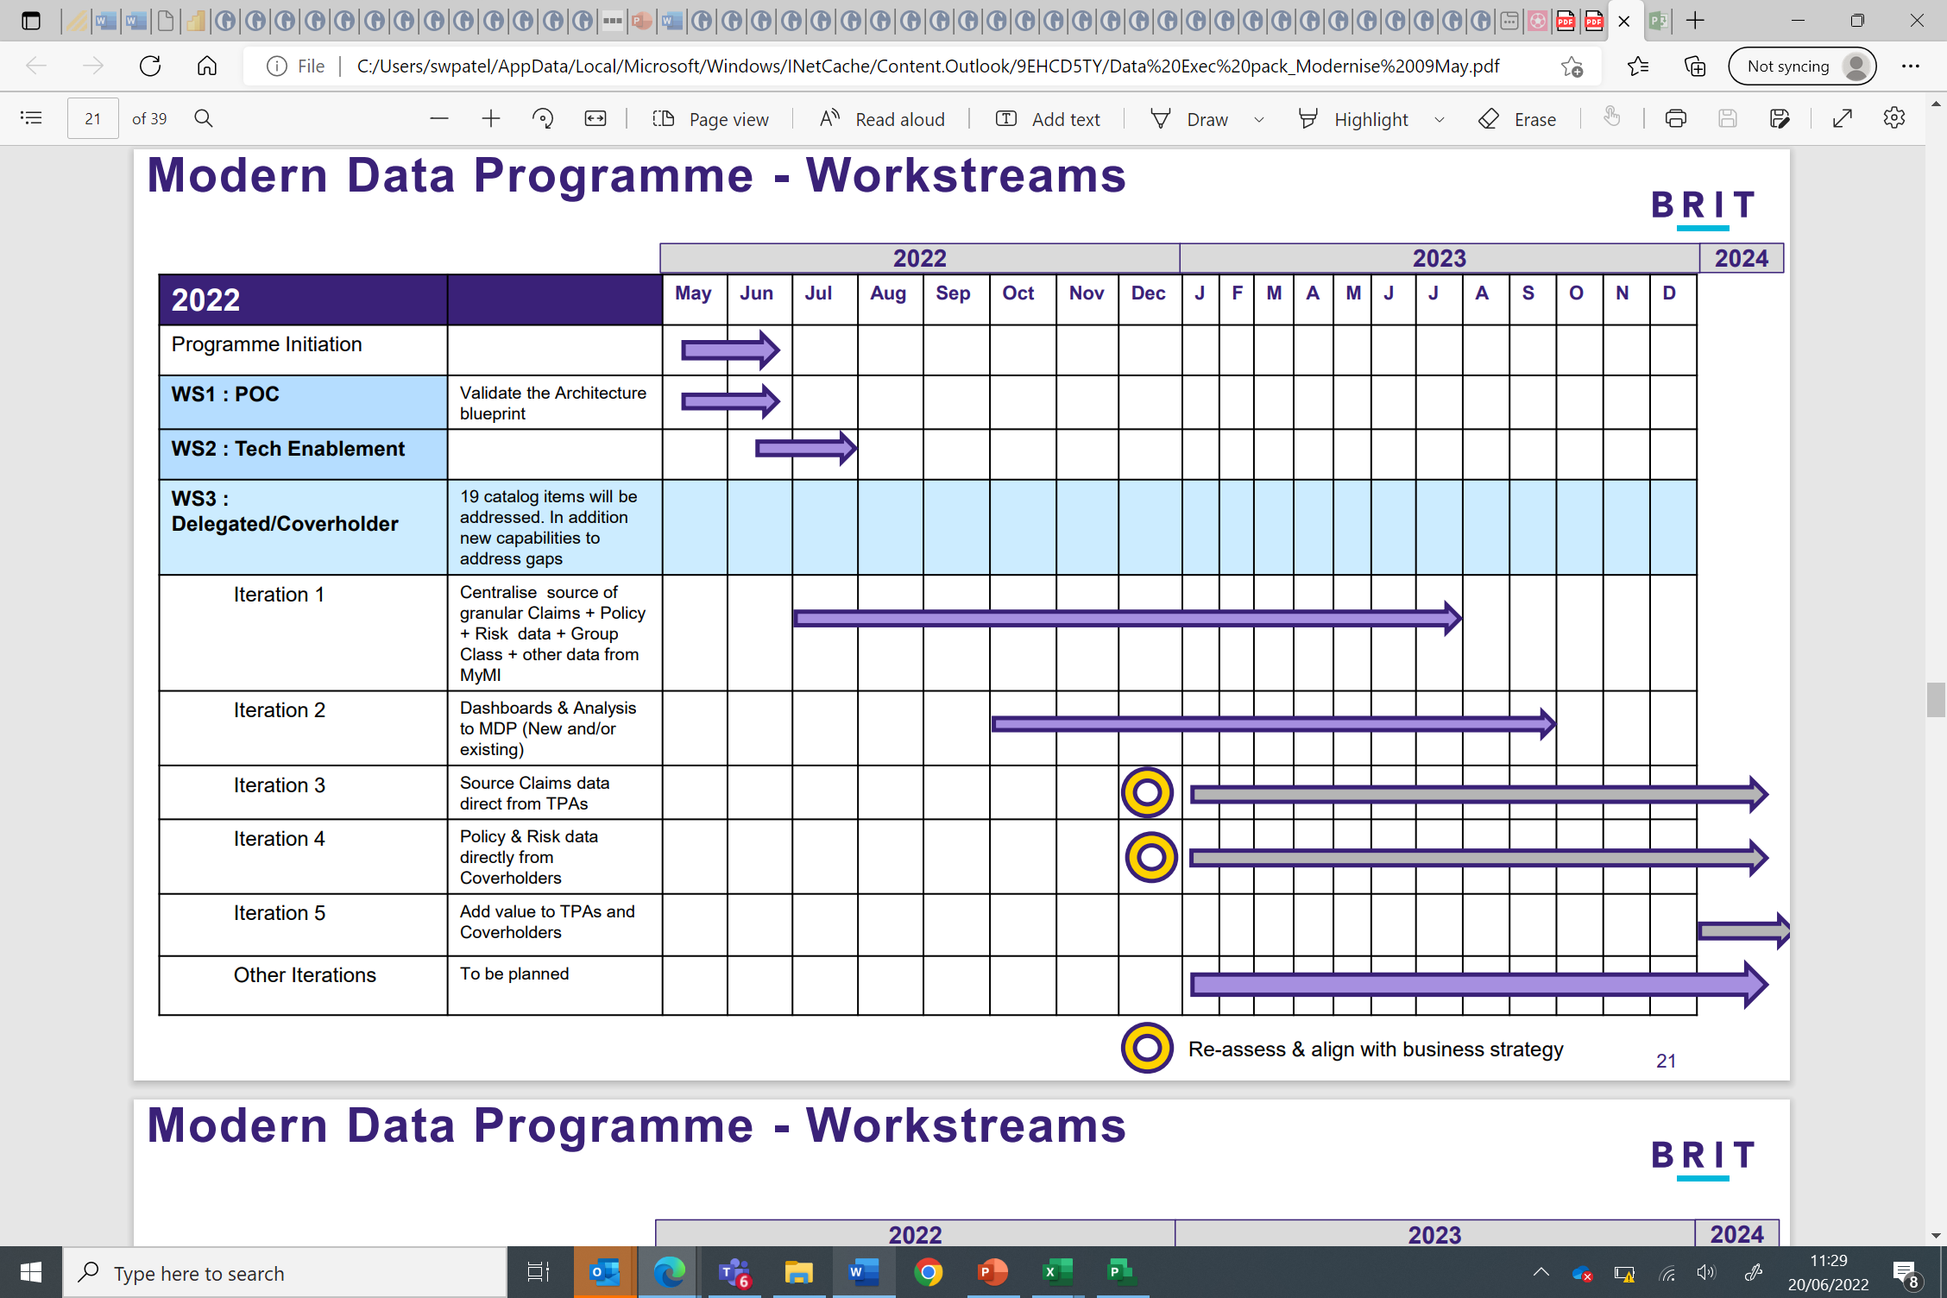

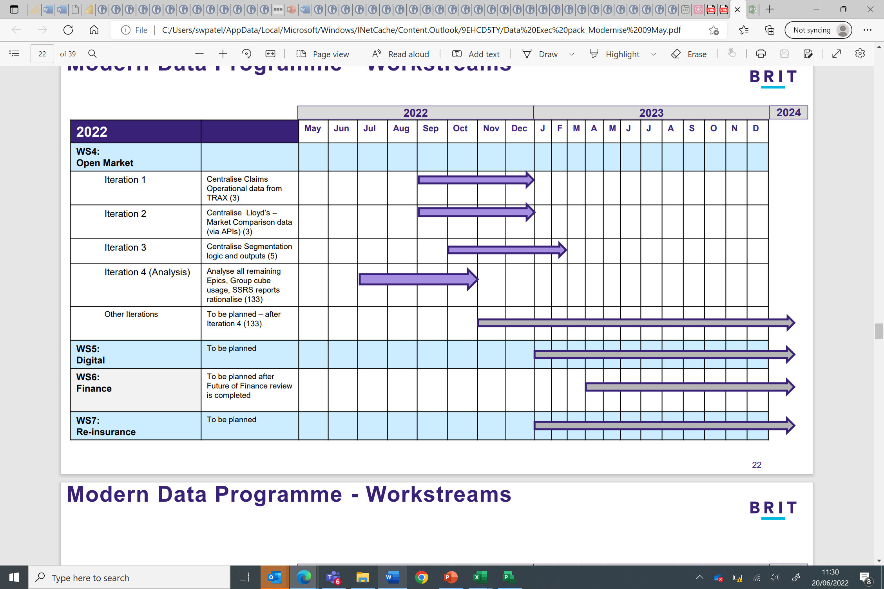

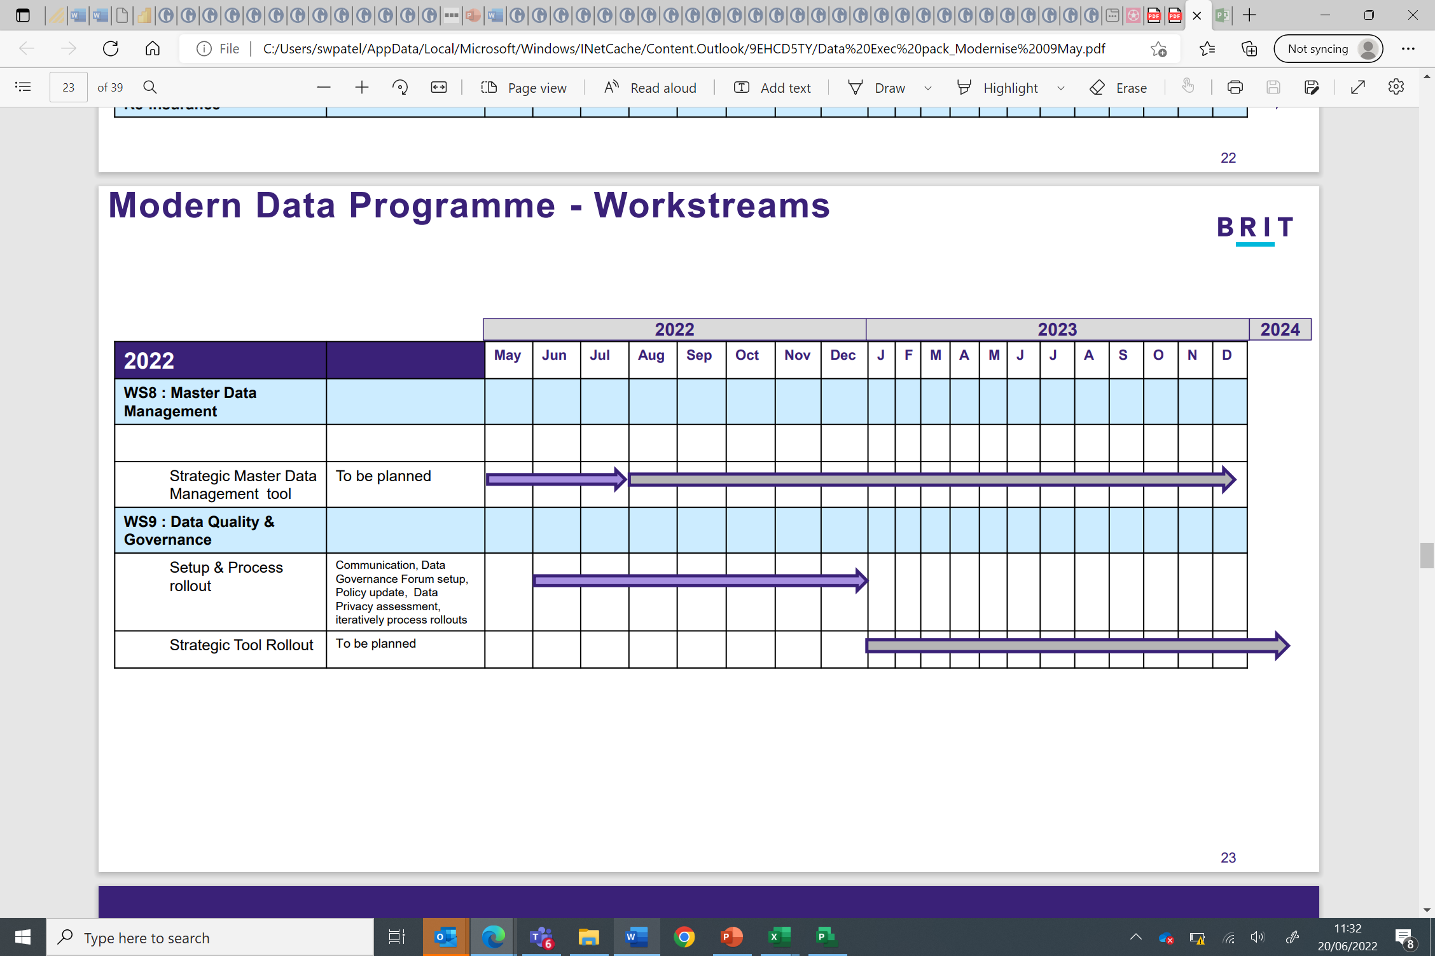

## Key Milestones

*List the key milestones to relect the deliverables from the ‘plan on a page’ and the ‘project deliverables’ table.*

| Milestone | Planned Date |
| --- | --- |
|  |  |
|  |  |
|  |  |
|  |  |

# Issue, Risk, Assumptions & Dependencies

## Issues

| **#** | **Issue** | **Resolution Approach / Action** |
| --- | --- | --- |
| 1 |  |  |
| 2 |  |  |

## Risks

| **#** | **Risk [EVENT leading to CONSEQUENCE resulting in EFFECT ON BUSINES OBJECTIVE.]** | **RAG**3 | **Mitigation** |
| --- | --- | --- | --- |
| 1 |  |  |  |
| 2 |  |  |  |

## Assumptions

| **#** | **Assumption** |
| --- | --- |
| 1 | Data will be able to be retained from one of the instances of the current data platform to avoid the reingestion or data migration from backup of the historical data |
| 2 | The modernised data platform will be built with a new use case initially, with further use cases being built out incrementally on it. Therefore the old data platform will not be able to be decommissioned until there is a critical mass of data on the new data platform to allow the existing reports to cut over to the new platform |
| 3 | Optimise and Stabilise work, to reduce the run cost of the current data platform will continue in parallel to the build out of the modernised data platform |
| 4 | Cost savings from the Optimise and Stabilise work will help to fund the investment in the modernised data platform, so that the project can remain as cost neutral as possible until value can be gained from the first use case |
| 5 | The existing data platform is significantly costly to change that the Business Value Goals identified across Claims, Underwriting and Finance would not be sustainable if they were deployed on the current data platform |

3 Red, Amber, Green definitions can be found in the Project Guidance document in the Project Delivery Framework.

## Dependencies

|  |  |  |  |  |
| --- | --- | --- | --- | --- |
| # | Depedency / Deliverable  (what is being delivered) | From Whom | To Whom | When |
|  |  |  |  |  |
|  |  |  |  |  |

# Business Case

## Estimated Project Costs

*Using the* [*Costs – Benefits Template*](https://teams.microsoft.com/l/file/5B45CCC4-AA58-4667-925E-8DC57636CE72?tenantId=8cee18df-5e2a-4664-8d07-0566ffea6dcd&fileType=xlsx&objectUrl=https%3A%2F%2Fbritgroupservices.sharepoint.com%2Fsites%2FITDelivery%2FShared%20Documents%2FIT%20Delivery%20Roadmap%2FControls%2FCost%20-%20Benefits%20Template.xlsx&baseUrl=https%3A%2F%2Fbritgroupservices.sharepoint.com%2Fsites%2FITDelivery&serviceName=teams&threadId=19:65e4174b4e1e4344826e53203a1382b4@thread.skype&groupId=b1630905-d554-43f9-bdf5-64fad147e876) *from the Project Delivery Framework insert the cost details from the ‘cost estimate’ tab. Ensure that you consider not only what the implementation costs will be but also the on-going run costs for a three year period following implementation.*



## Benefits

*Using the* [*Costs – Benefits Template*](https://teams.microsoft.com/l/file/BBBB3368-9146-4FAD-A6F2-29AE61933A9D?tenantId=8cee18df-5e2a-4664-8d07-0566ffea6dcd&fileType=xlsx&objectUrl=https%3A%2F%2Fbritgroupservices.sharepoint.com%2Fsites%2FITDelivery%2FShared%20Documents%2FIT%20Delivery%20Roadmap%2FControls%2FCost%20-%20Benefits%20Template%20.xlsx&baseUrl=https%3A%2F%2Fbritgroupservices.sharepoint.com%2Fsites%2FITDelivery&serviceName=teams&threadId=19:65e4174b4e1e4344826e53203a1382b4@thread.skype&groupId=b1630905-d554-43f9-bdf5-64fad147e876) *from the Project Delivery Framework insert the financial and non-financial benefit estimates from the ‘Benefits – Before & After’ tab, with their underpinning assumptions regarding what changes will be made in the business to deliver the benefits.*



# Governance of the Project

## Steering Committee Terms of Reference

### Members

*Ensure that the SteerCo membership reflects the teams who are impacted by the implementation. Consider whether or not the third party or implementation partner should be a member. Aim should be to have the smallest possible SteerCo while ensuring all key areas are represented*

|  |  |  |
| --- | --- | --- |
| **Role** | **Department** | **Name** |
| Executive Sponsor |  |  |
| Business Sponsor |  |  |
| Senior User |  |  |
| Senior Supplier |  |  |
| Other |  |  |
| Risk |  |  |

When SteerCo members are not able to attend it is important that empowered deputies are provided to ensure that the project can proceed.

### Frequency / Duration

SteerCo will meet at least monthly.

### Inputs

The SteerCo will be provided with a report at least two days before the meeting and it will contain the following sections:

* Exec Summary - the ‘status on a page’ report that will be shared with the Change function as the SteerCo deck is issued to report into the Strategic Change Board.
* Decisions to be taken – with supporting information as required.
* Actions – from previous SteerCos with update on progress
* Plan on a Page– summary of key workstreams and milestones and indication of whether or not they are on track
* Progress Update– summary view of key achievements and upcoming milestones / activity
* Issues – including assessment of criticality and actions to resolve
* Risks - including assessment of RAG and mitigations
* Budget Update– information on Budget – Actuals – Forecast
* Sponsor Requested Content– as appropriate

### Outputs

Minutes to cover actions and decisions. Minutes to issued within two working days of the SteerCo meeting. Minutes to be stored in location XXX

## Working Group Membership:

*If it is appropriate to have a working group to operate in support of the SteerCo then list who will be involved in what capacity. Ensure that the membership reflects the teams who are impacted by the implementation. Consider whether or not the third party or implementation partner should be a member. Indicate how frequently the working group will meet and what its responsibilities will be.*

It is assumed that the working group members will participate in project related workshops and where required will be asked to dedicate time to project specific activity.

|  |  |  |
| --- | --- | --- |
| **Role** | **Department** | **Name** |
| Business Sponsor |  |  |
| Senior User |  |  |
| Senior Supplier |  |  |
| Other |  |  |
| Risk |  |  |

## Project Team:

*Detail who will make up the project team to perform what roles, and what percentage of their time will allocated to the project.*

|  |  |  |  |
| --- | --- | --- | --- |
| # | Role | Name | % of time allocated to project |
| 1 | **Project Manager** | Jason Green |  |
| 2 | **Business Analyst** | Akhila Mathews |  |
| 3 | **Solution Architect** | Ricardo Pedro, Graham Binner |  |
| 4 | **Developer** |  |  |
| 5 | **Tester** |  |  |

*Specify how frequently the project team will meet.*

# Project Deliverables (TBC)

*Indicate which deliverables from the Project Delivery Framework will be required / delivered by the project.*

| **Phase** | **Workstream** | **Deliverable** | **Type**  **(Mandatory or Optional)** | **Required for this project?** | **Reason – if not required** |
| --- | --- | --- | --- | --- | --- |
| Initiation | Controls | Project Brief | Optional |  |  |
|  |  | **Project Initiation Document** | **Mandatory** |  |  |
|  |  | **Plan** | **Mandatory** |  |  |
|  |  | RAID (PPM) | Optional |  |  |
|  |  | **Status Reports** | **Mandatory** |  |  |
|  |  | **Financial Tracker (PPM)** | **Mandatory** |  |  |
|  | Agile | Product Backlog | Optional |  |  |
|  | Data | Info Security Checklist | Mandatory – for IT projects |  |  |
|  | Technology | Business Requirements Document | Optional |  |  |
|  |  | Architecture Blueprint | Optional |  |  |
|  |  | Test Strategy | Optional |  |  |
|  |  | Service Readiness Scope & Approach | Mandatory – for IT projects |  |  |
|  | Process | As-Is Process Maps | Optional |  |  |
|  |  | To-Be Process Maps | Optional |  |  |
|  |  | KPI Framework | Optional |  |  |
|  | People | Change Impact Assessment | Optional |  |  |
|  |  | Change Management Approach | Optional |  |  |
|  |  | Stakeholder Map | Optional |  |  |
|  |  | Communications Approach | Optional |  |  |
| Plan | Controls | Business Readiness Acceptance Criteria | Optional |  |  |
|  |  | Change Requests | Optional |  |  |
|  | Agile | Sprint Backlog | Optional |  |  |
|  |  | User Stories | Optional |  |  |
|  |  | Burndown Charts | Optional |  |  |
|  | Data | Data Migration Plan | Optional |  |  |
|  | Technology | Low Level Solution Design | Optional |  |  |
|  |  | Low Level Service Design | Optional |  |  |
|  |  | Test Plan | Optional |  |  |
|  |  | Traceability Matrix | Optional |  |  |
|  |  | Service Readiness Plan | Mandatory – for IT projects |  |  |
|  | People | Training Appraoch & Plan | Optional |  |  |
|  |  | Communications Execution Plan | Optional |  |  |
|  |  | Change Champion Network | Optional |  |  |
| Delivering | Agile | Unit Test Case | Optional |  |  |
|  |  | Functional Test Case | Optional |  |  |
|  |  | Automated Regression Test Report | Optional |  |  |
|  |  | Sprint Demo | Optional |  |  |
|  |  | Sprint Retrospective | Optional |  |  |
|  | Data | Data Migration Execution Plan | Optional |  |  |
|  | Technology | Test Scripts | Optional |  |  |
|  |  | Defects Log | Optional |  |  |
|  |  | Test Completion Report | Optional |  |  |
|  |  | Decommisioning Report | Optional |  |  |
|  |  | Service Readiness Execution Plan | Mandatory – for IT projects |  |  |
|  | Process | KPI Dashboard | Optional |  |  |
|  | People | Standard Operating Procedures | Optional |  |  |
| Close | Controls | **Closure Report** | **Mandatory** |  |  |
|  |  | Benefits Realisation Report | Optional |  |  |

# Mandatory Checklists

## General Data Protection Regulation (GDPR) checklist

Please contact Tim Harmer if you have questions on GDPR

|  |
| --- |
| Checklist Updated May 2018 |
| Within your project aims and objectives, do you intend to process personal data?  Personal data is any information (including by linking to other available sources) by which an individual can be identified such as names, addresses, e-mail addresses, telephone numbers or policy numbers. | Yes | No  If no then please disregard following questions |
| Within your project aims and objectives, is it planned to process ‘special category’ data on a large scale? Special category personal data is data that reveals:  racial or ethnic origin,  political opinions,  religious or philosophical beliefs,  trade union membership,  the processing of genetic data,  biometric data for the purpose of uniquely identifying a natural person,  data concerning health or data concerning a natural person’s sex life or sexual orientation | Yes | No |
| Is it planned to carry out systematic monitoring of publically accessible personal data on a large scale?  Examples of publicly accessible personal data:  Connecting to Facebook?  Connecting to telephone directories?  Automatic name and address look-ups etc? | Yes | No |
| Is it planned to carry out systematic evaluation of personal data by automated processing i.e. profiling? | Yes | No |
| If you answer yes to any of the above questions then your Project will need to include a review with the Data Protection Officer (DPO) to ensure the necessary records are kept to demonstrate compliance to GDPR and ensure the necessary entries are recorded within the Data Asset Register.  Is a review with the DPO required? | Yes | No |

## 

## SOX Financial Controls Framework

Please contact the Financial Controls Team (Rhod Newcombe and Caroline Kick) to discuss whether the project is likely to have a Sox Impact.

|  |  |  |
| --- | --- | --- |
| **Sox Implication** | Yes | No |
| **Reason for decisions** | This project represents no net change from the current provisioning of systems and therefore does not present any impact on SOX controls | |
| **Financial Controls Team Approval for decision**  **(Please obtain physical signature)** | Confirmed N/A by Rhod Newcombe | |

## Cyber Engagement Checklist

Please Review the Information Security Checklist to determine which elements are to be completed, for any queries please contact Keith Awcock.

|  |  |  |  |
| --- | --- | --- | --- |
| **Artefact** | **Completion Required** | **If not to be completed, please provide details as to why** | **Completion Date** |
| [Information Security Checklist](https://teams.microsoft.com/l/file/79E40DD1-5BF3-45A6-8D45-5061E061C0E7?tenantId=8cee18df-5e2a-4664-8d07-0566ffea6dcd&fileType=xlsx&objectUrl=https%3A%2F%2Fbritgroupservices.sharepoint.com%2Fsites%2FInformationSecurityChecklist%2FShared%2520Documents%2FGeneral%2F_Templates%2FInformation-Security-Checklist%2520v2.xlsx&serviceName=teams&threadId=19:2cefe360a0af4406a962d8f67619ca10@thread.skype&groupId=c35430d5-f43c-4236-9083-26d1d9e693fc) | Y |  |  |

# Engagement Checklist

*It is important to ensure that those who may be impacted by the project have been consulted. In the table below indicate which functions and individuals have been consulted, and if not why not. Please ensure that the head of department is engaged if there are any business resource impacts.*

| Function | Person Engaged | Date engaged | Reason if not engaged |
| --- | --- | --- | --- |
| Claims | Stephen Rimmer |  |  |
| Finance – Business Planning | Paul Spragett |  |  |
| Finance – Regulatory Reporting | Gavin Sibbick |  |  |
| Finance – Financial Control | Antony Usher |  |  |
| Compliance | Tessa Dixon |  |  |
| Legal / Co. Sec | Tim Harmer |  |  |
| Ops Management | Tunu Sokiri |  |  |
| DUMU | Susan Andrew |  |  |
| Group UW Services (GUS) | Janet Henderson |  |  |
| IT | Simon Lumdson |  |  |
| Underwriting | Related MDs |  |  |
| Risk | Micheline Hart |  |  |
| Actuarial | Richard Weston |  |  |
| HR | Louise Akibu |  |  |
| Data Governance,Governance Reporting & Analysis | Ben Steele |  |  |
| ORI | Paul Metson |  |  |
| BGSU | Adam Finkle |  |  |
| Innovation | James Birch |  |  |
| Infosys | Sue Ogilvy |  |  |
| Procurement | Sue Ogilvy |  |  |
| Internal Audit | David Kelly |  |  |
| MI & Reporting Team | Caroline Beardsell |  |  |
| Facilities |  |  |  |
| Distribution | Joy Ferneyhough |  |  |
| Other |  |  |  |

1. Role of Approver: Formal agreement to proceed with the project on the basis of the PID
2. Role of Reviewer: Provides review comments to enhance PID clarity